CTF CHALLENGE WRITEUP
H3h3
Forensics / Steganography | Easy | 50 Points

Challenge
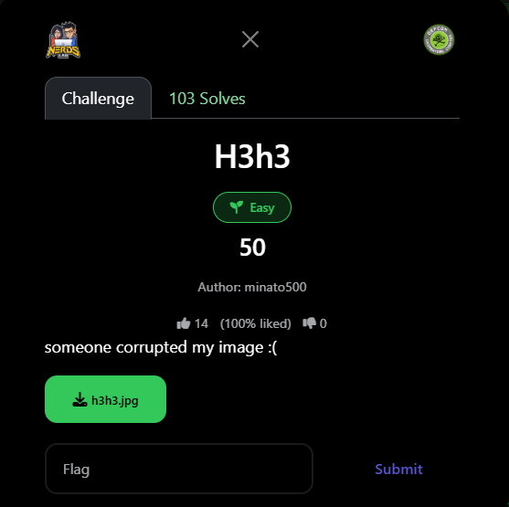
Figure 1: Challenge page as presented in the CTF platform

Challenge Information
Challenge Name | H3h3
Category | Beginner
Difficulty | Easy
Points | 50
Author | minato500
Solves | 103
Description | someone corrupted my image :(
Flag | defcon{m4g1c_byt3_h4s_b33n_c0rrupt3d}

Step 1: File Triage
The challenge provided a file named h3h3.jpg. The name and extension suggest a JPEG image, but the description warns "someone corrupted my image :("

The first step in any file forensics challenge is to inspect the raw bytes — specifically the magic bytes (file signature) at the very start of the file, which identify the file type.

Inspecting the Magic Bytes
data = open('h3h3.jpg','rb').read()
print(data[:12].hex())
# Output: ffffffffffffffffffff ffff

A valid JPEG file must begin with the SOI marker: FF D8. Instead, the first 12 bytes were all 0xFF. This is the corruption — the JPEG magic header was overwritten with FF bytes.

Valid JPEG header (bytes 0–11) | FF D8 FF E0 00 10 4A 46 49 46 00 01
Corrupted file (bytes 0–11) | FF FF FF FF FF FF FF FF FF FF FF FF
File bytes from position 12 | 01 00 00 48 00 48 00 00 FF DB … (intact)

Crucially, byte 12 onwards matched the expected JFIF header continuation (version, density, thumbnail bytes), confirming that only the first 12 bytes were corrupted.

Step 2: Restore the JPEG Magic Header
Since only the first 12 bytes were overwritten, the fix is straightforward: prepend the correct JFIF header bytes and append the rest of the file unchanged.

Python Fix Script
data = open('h3h3.jpg', 'rb').read()

# Correct JFIF header first 12 bytes
jfif_header = bytes([
0xFF, 0xD8, # SOI - Start of Image
0xFF, 0xE0, # APP0 - JFIF marker
0x00, 0x10, # APP0 length = 16 bytes
0x4A, 0x46, # 'JF'
0x49, 0x46, # 'IF'
0x00, 0x01 # null terminator + version
])

fixed = jfif_header + data[12:] # replace corrupted header
open('fixed_h3h3.jpg', 'wb').write(fixed)

The fixed file was verified by opening it with Pillow:
from PIL import Image
img = Image.open('fixed_h3h3.jpg')
print(img.size) # (879, 1000) - valid image!

Step 3: Flag Recovered
Opening the restored image revealed the flag written in plain text at the top of the image:

FLAG: defcon{m4g1c_byt3_h4s_b33n_c0rrupt3d}

The flag is a meta-reference to the challenge itself: "magic bytes has been corrupted" — written in leet-speak (m4g1c byt3 h4s b33n c0rrupt3d).

Proof — Recovered Image
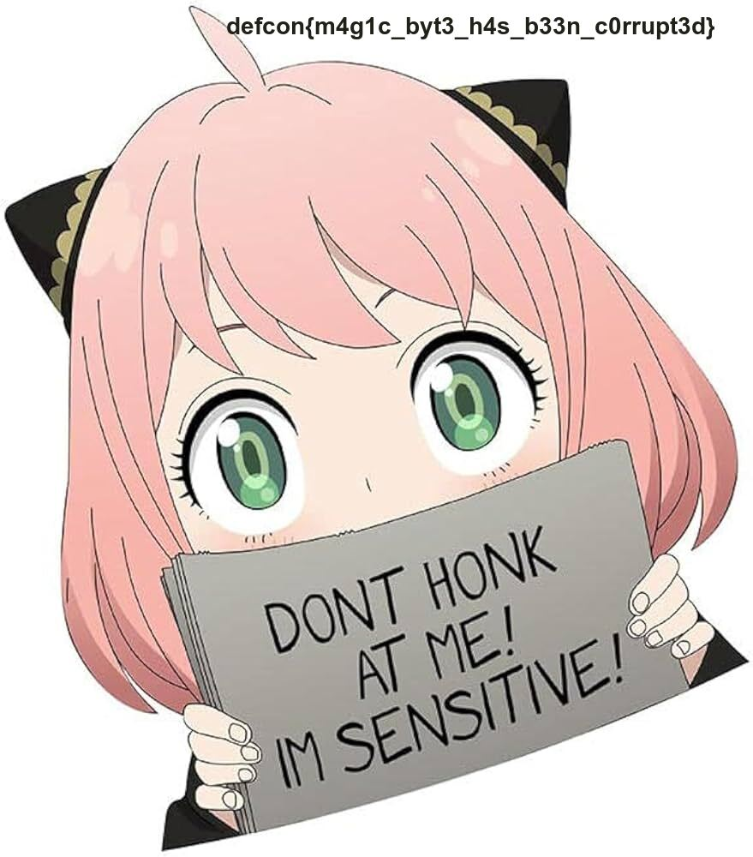
Figure 2: Fixed h3h3.jpg — flag visible at top: defcon{m4g1c_byt3_h4s_b33n_c0rrupt3d}

Lessons Learned
- Magic bytes are critical: Every file format has a unique signature at byte offset 0. JPEG = FF D8, PNG = 89 50 4E 47, PDF = 25 50 44 46. Corruption of these bytes makes the file unreadable but the data is still intact.
- Partial corruption is easy to fix: When only the header is overwritten, restoring the known good header bytes is all that is needed. The image data itself was perfectly intact from byte 12 onward.
- Hex analysis first: Always inspect raw bytes before assuming a file is truly broken. Tools like Python, xxd, or HxD reveal what is actually wrong immediately.
- Flag was in plain sight: Once the file was repaired and opened, the flag was embedded as visible text in the image — no steganography or further analysis required.

DEFCON CTF — H3h3 — Solved

